32nd Sunday in Ordinary Time.
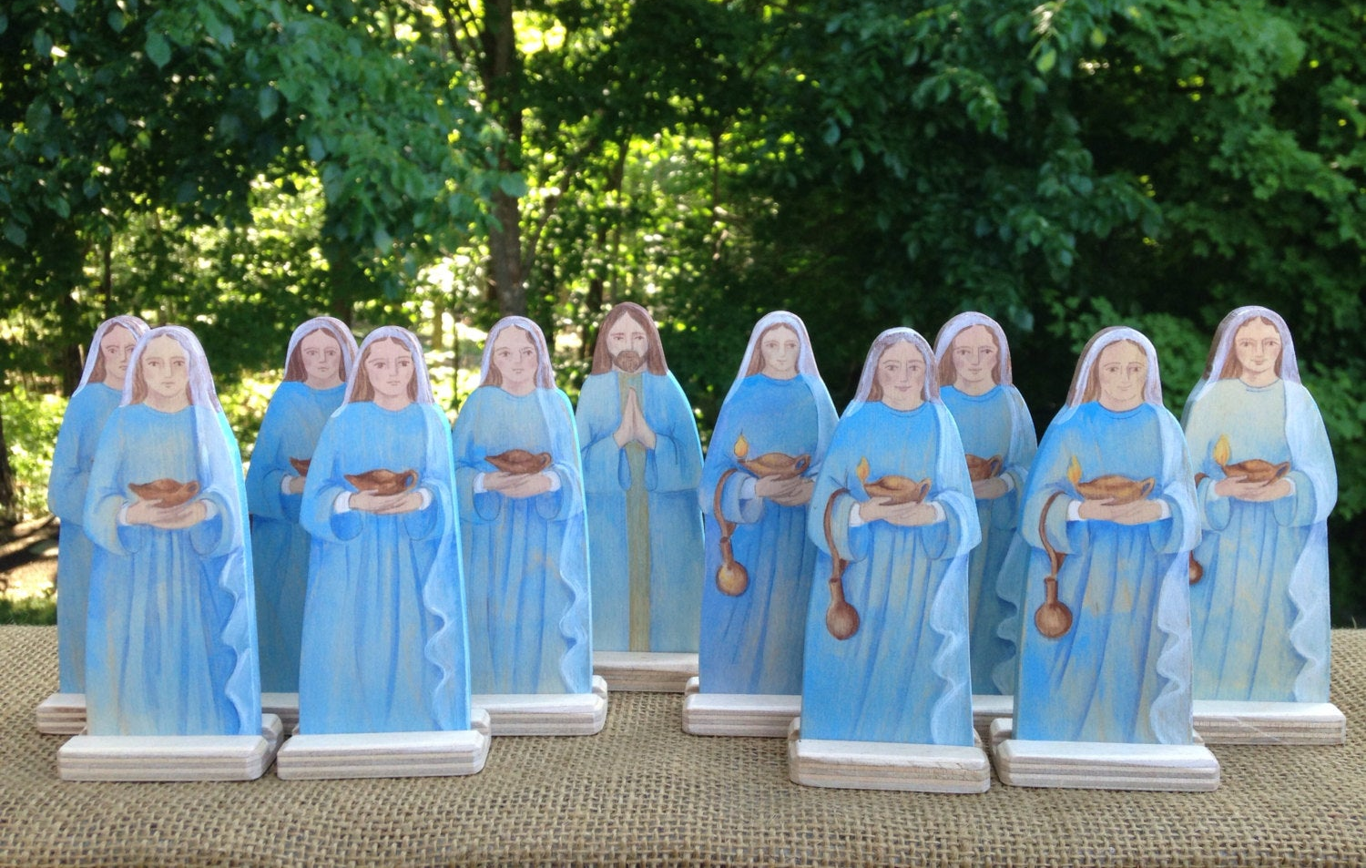

1st Reading: Wisdom 6:12-16
In praise of Wisdom, which is easily discerned by those who love her
Wisdom is radiant and unfading, and she is easily discerned by those who love her,
and is found by those who seek her.
She hastens to make herself known to those who desire her.
One who rises early to seek her will have no difficulty, for she will be found sitting at the gate.
To fix one’s thought on her is perfect understanding; one who is vigilant on her account will soon be free from care, because she goes about seeking those worthy of her, and she graciously appears to them in their paths, and meets them in every thought.
Responsorial: Psalm 62:2-8
Response: My soul is thirsting for you O Lord my God
O God, you are my God, for you I long;
for you my soul is thirsting.
My body pines for you
like a dry, weary land without water. Resp:
So I gaze on you in the sanctuary
to see your strength and your glory.
For your love is better than life,
my lips will speak your praise. Resp:
So I will bless you all my life,
in your name I will lift up my hands.
My soul shall be filled as with a banquet,
my mouth shall praise you with joy. Resp:
On my bed I remember you.
On you I muse through the night
for you have been my help;
in the shadow of your wings I rejoice. Resp:
2nd Reading: 1 Thessalonians 4:13-18
We should not grieve as others do who have no hope
But we do not want you to be uninformed, brothers and sisters, about those who have died, so that you may not grieve as others do who have no hope. For since we believe that Jesus died and rose again, even so, through Jesus, God will bring with him those who have died. For this we declare to you by the word of the Lord, that we who are alive, who are left until the coming of the Lord, will by no means precede those who have died.
For the Lord himself, with a cry of command, with the archangel’s call and with the sound of God’s trumpet, will descend from heaven, and the dead in Christ will rise first. Then we who are alive, who are left, will be caught up in the clouds together with them to meet the Lord in the air; and so we will be with the Lord forever. Therefore encourage one another with these words.
Gospel: Matthew 25:1-13
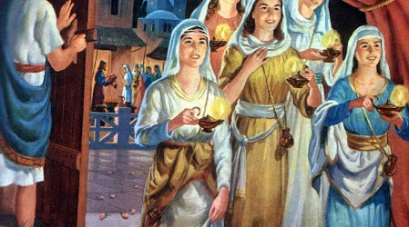
We must be ready to meet the Lord when he comes
Jesus told this parable to his disciples: “The kingdom of heaven will be like this. Ten bridesmaids took their lamps and went to meet the bridegroom. Five of them were foolish, and five were wise. When the foolish took their lamps, they took no oil with them; but the wise took flasks of oil with their lamps. As the bridegroom was delayed, all of them became drowsy and slept. But at midnight there was a shout, ‘Look! Here is the bridegroom! Come out to meet him.’ Then all those bridesmaids got up and trimmed their lamps. The foolish said to the wise, ‘Give us some of your oil, for our lamps are going out.’ But the wise replied, ‘No! there will not be enough for you and for us; you had better go to the dealers and buy some for yourselves.’ And while they went to buy it, the bridegroom came, and those who were ready went with him into the wedding banquet; and the door was shut. Later the other bridesmaids came also, saying, ‘Lord, lord, open to us.’ But he replied, ‘Truly I tell you, I do no know you.’ Keep awake therefore, for you know neither the day nor the hour.”

Reflections:

Life after Death .....

Our present-day western civilisation derives, in great part, from Greek, Roman and Jewish cultures. But in attitudes, in ancient times, towards life after death, there could be no greater gap between, on the one hand, the Graeco-Roman tradition, and on the other, the Jewish tradition. In particular, when confronted with the inevitability of death, the response of the person without faith was, and today is, one of despair. On a pagan tomb-stone from the classical period can be read the grim inscription, “I was not, I became; I am not, I care not.” Essentially it means: “When you’re dead, you’re dead!” In similar vein, the Roman lyric poet, Horace, who died the year Christ was born, had this advice for the reader: “Enjoy the present day, and trust in tomorrow as little as you can.” (Carpe diem, quam minimum credula postero). No wonder then that he motto of the time was, “Eat, drink, and be merry, for tomorrow we die.”
In the Jewish tradition, belief in resurrection after death did not gain acceptance until the first century before Christ. But there was belief in a shadowy existence of the departed in a place called Sheol, where they could neither know God nor praise him. If we take the Book of Ecclesiastes, for example, written about 300 B.C., we find its author agreeing, yes, there can be a certain happiness in eating, drinking and being content with one’s work while on earth, but because of the futility of earthly pursuits and possessions, there is in human beings a God-given yearning for something deeper, especially for the meaning of all experience and all time. And God is the only one who is wise, the only one who knows.
In a chapter full of vivid imagery, the author of Ecclesiastes describes how, without being touched in the least by the passing of man to his eternal abode, the things of nature carry on with their own pursuits. Even those who mourn the passing from this life of one of their own are already walking to and fro in the street before, as the writer says, “the silver cord is snapped, or the golden lamp (of life) is broken, or before the dust returns to the earth from whence it came, and the spirit to God who gave it.” There is some element in each person which this world is not worthy to retain; it is of God, and after its sojourn here it returns to God.
The greatest change in attitude to life hereafter came about with belief in the resurrection of Christ. “For us,” St Paul wrote to the Philippians (Phil 3:20), “Our homeland is in heaven, and from heaven comes the Saviour we are waiting for, the Lord Jesus Christ, and he will transfigure these lowly bodies of ours into copies of his own glorious body.” We should not therefore, he tells us in the liturgy today, remain without understanding concerning those close to us who have passed away.
We should not grieve as others do, who have no concept of eternal life. Note, he does not tell us to avoid all sorrow, for sorrow over the death of a loved one is a natural reaction, but rather not to be like others, who have no hope. The necessity of losing somebody in death causes us anguish, but hope consoles us. Our human frailty is tried by the one, but our faith is strengthened by the other. The liturgy this month asks us to respond in two practical ways. Firstly, it tells us to be prepared, not to let things go too late. No tolling funeral bell can cause greater anguish than the words “too late.” Those who live all their lives close to Christ will never be un-prepared to enter his presence, will be with Christ even in death, and will finally share in his glorious resurrection. Secondly, it invites us to assist with our prayers those who have gone before us.
St Monica was always anxious to be buried alongside her husband, but when she was dying at Ostia, the port of Rome, she made this last request to her son, Augustine, “Lay this body anywhere,” she said, “let it not be a care to you. This only I ask of you, that you would remember me at the Lord’s altar wherever you may be.” We too should keep in mind that in death life is changed, not ended. This is our Christian hope; this is our God-given trust.
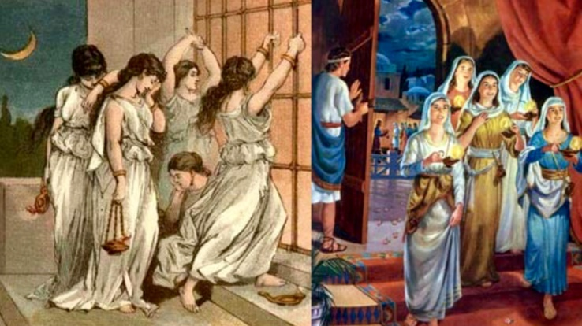
From these reflections on life after death, particularly during this month of November, we read the Gospel Passage of this 32nd Sunday in Ordinary Time again and reflect on our present life:

The wedding banquet is a consistent image of eternal life in the New Testament. We can only speak about the un-known and un-familiar in terms of what is known and familiar. The wedding banquet highlights eternal life as that state in which the deepest hunger and thirst in our lives will be satisfied, especially the hunger and thirst for love, for God who is love. “My soul is thirsting for you O Lord my God” (Responsorial Psalm). In the second reading, Paul. without making use of the banquet image, speaks of life beyond death in a similar vein – it is that eternal moment when “God will bring with him those who have died” and when “we shall stay with the Lord forever.” Eternal life will mean entering into a new” and fuller relationship with God and, through him, with all creation.
Yet, the parable warns us that it is possible to exclude ourselves from the banquet of eternal life. It was only those who were ready, who went in with the bridegroom to the wedding hall. When God comes to bring us, will we be ready? Life, including life after death is God’s gift to us and a gift, by definition, can be refused. However, we will certainly be ready to accept this ultimate gift, if throughout our lives we have learned to be receptive to God. Our daily attitudes will determine our attitude at the moment of death. Today’s Gospel concludes with a ringing exhortation “Stay awake.” One important way in which we stay awake to God is prayer. “Why are you sleeping?” Jesus asked his friends, “get up and pray” (Luke 22:46.) To pray is to awaken to the Lord who is always awake to us. In prayer we look for the Lord, desire him, watch for him and think about him. To pray is to become like a child, to grow in receptivity to God’s presence within us. Amen.
